

Ecommerce Applications Development

Diploma in Information Technology

AY 2023/24 Semester 2

Team cum Individual Assignment
(30% of Overall Assessment)

Duration: Week 16 - 17

Deadline for Submission:
3rd February 2024 (Sunday), 12:00 PM

Class group | : | P03
Tutor | : | Anand Ravi Despande
Team ID | : | 2
Date of submission | : | 2nd February 2024
Late | : | YES / NO

Please fill in your Student Number and Name as appeared on your student card:

Functions | Student ID | Student Name | Team Grade | Grade
Shopping Cart | S10227735B | Ong Jia Yuan
Checkout | S10222049J | Owen Wong Hoi Yang
Product Catalog | S10222747H | Khoo Jun Jie

Penalty for late submission:
10% of the marks will be deducted every day after the deadline.
No submission will be accepted after 10th February 2024, 12:00 pm.

Table of Contents
Pages
Integration of System (Group Component) 3
Done By: Everyone 3
Login Page 5
Product Catalog (Individual Component) 6
Done By: Khoo Jun Jie S10222747H 6
Product Categories 6
Product Listing 7
Product Details 8
Product Search 10
Shopping Cart (Individual Component) 12
Done By: Ong Jia Yuan S10227735B 12
Shopping Cart Overview 12
Add Item to Shopping Cart 13
Display and Update Shopping Cart Contents 15
Dynamic Shopping Cart Indicator 17
Delivery Fee Waiver Notification 18
Pricing reflects Item price after sale 19
Checkout (Individual Component) 21
Done By: Owen Wong Hoi Yang S10222049J 21
Shopping Cart Delivery 21
Not Enough Stock 23
PayPal 24
Order Confirmation page 26
Payment Breakdown 27
Print Receipt 28
References 29

Integration of System (Group Component)

Done By: Everyone

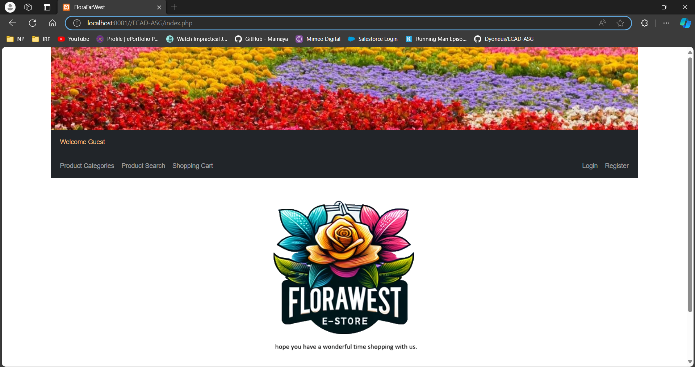

Site Name: FloraFarWest

FloraFarWest is an enchanting online storefront offering a vibrant selection of floral arrangements and garden essentials to patrons across Singapore. This website is a haven for garden enthusiasts and those seeking to infuse their spaces with the natural beauty of flowers.

Our virtual store boasts an intuitive and minimalist design with our emblematic logo positioned at the upper left corner of the webpage. Directly beneath it lies a streamlined navigation bar, leading you seamlessly through the diverse categories of offerings. Recognizing the importance of accessibility, our website is crafted to be fully responsive. The navigation bar conveniently transforms into a compact dropdown menu on smaller screens, ensuring an effortless browsing experience on mobile devices.

The aesthetic of FloraFarWest is characterized by a palette of soothing colors—crisp white, verdant green, and floral accents—that mirror the tranquility of a blooming garden. White serves as the backdrop for clarity and freshness, while green shades represent growth and vitality, adorning the navigation bar. Accent colors drawn from our floral selection are peppered throughout the site, highlighting key features and buttons for navigation.

Prominently displayed, our logo and brand name at the middle of the page serve as a constant reminder of the FloraFarWest experience. A click on the picture above will always guide visitors back to our home page.

The main page greets visitors with a warm welcome message, set against the backdrop of our lush floral collection, instantly conveying the essence of our product range. Special deals and featured blooms are showcased here, inviting customers to explore the beauty on offer.

For assistance or inquiries, customers are welcomed to reach out through our dedicated contact channel at florafarwest@np.edu.sg. Copyright and legal information is discreetly placed in the footer, maintaining the clean and uncluttered design of our site. FloraFarWest is designed for ease, mirroring the simplicity and beauty of nature, while providing a seamless shopping experience for all things floral.

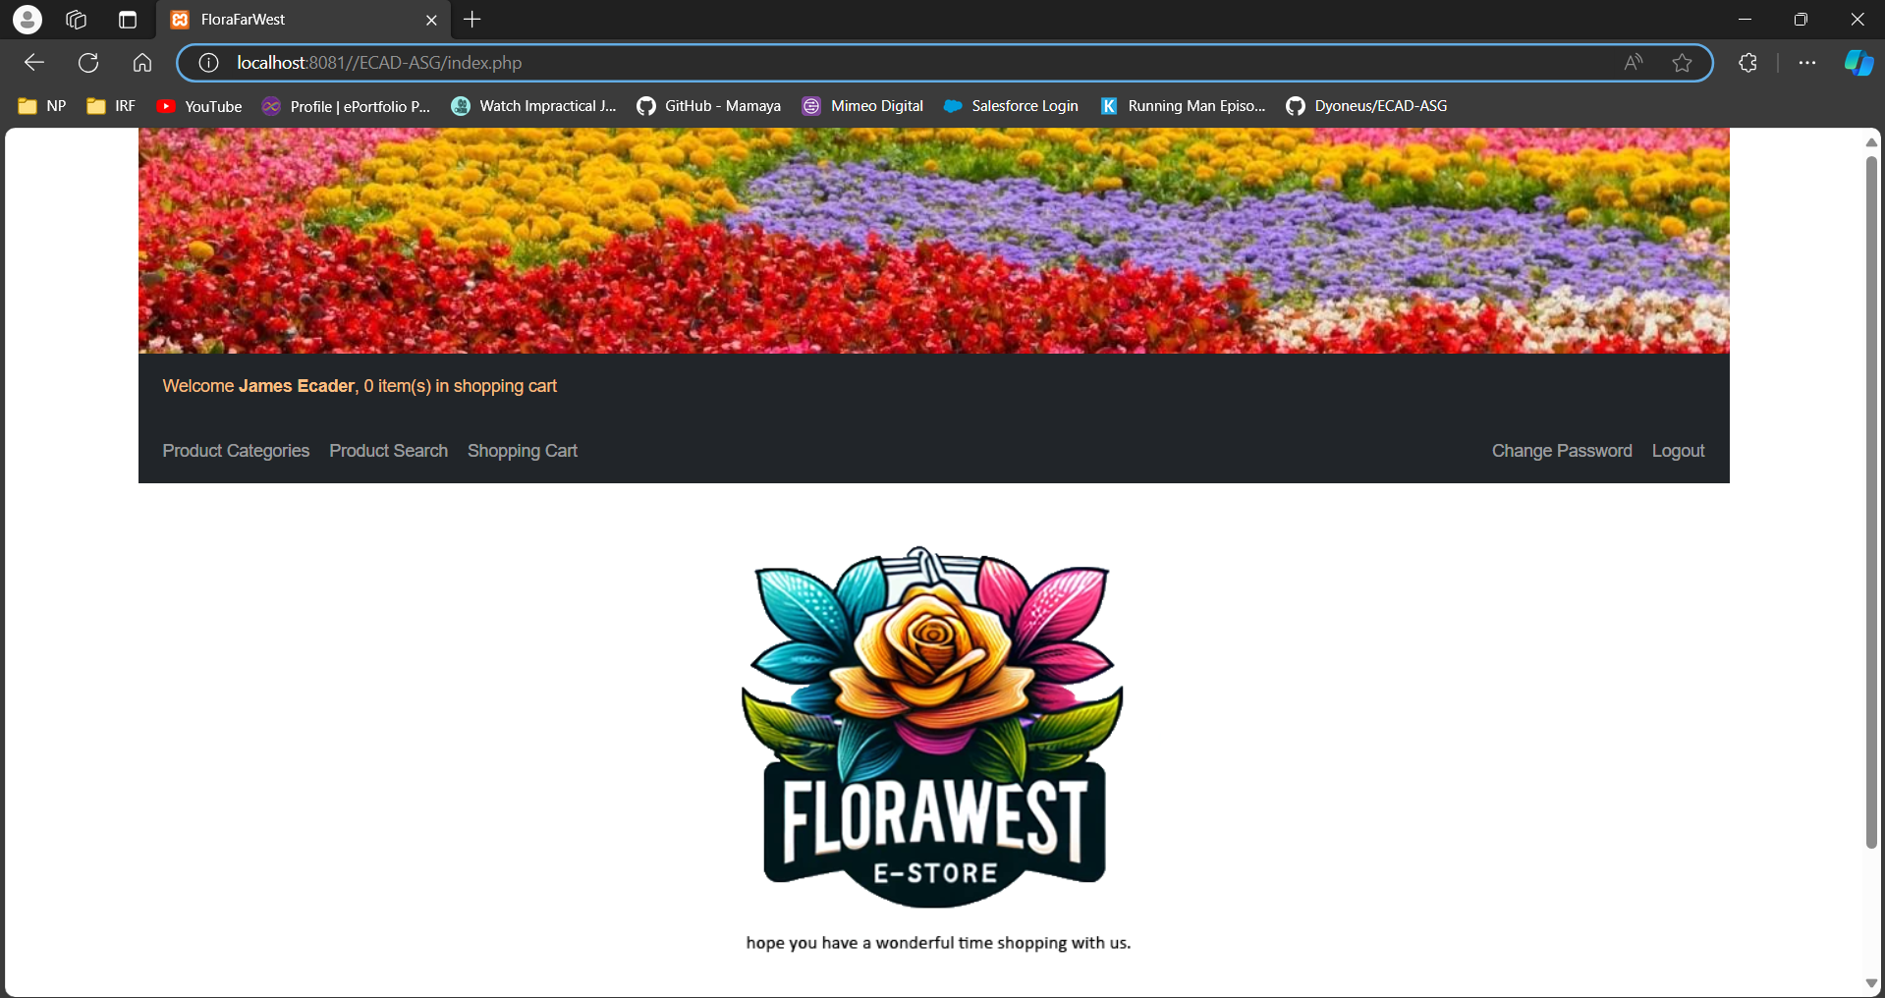

This is the default home page of FloraFarWest which contains links to other pages of the website and allows the accessing of other functions. Assuming the user has logged in as shown in the screenshot above, the other pages and functionalities of the website that the user can access would be the “Product Categories”, “Product Search”, “Shopping Cart”, “Change Password” and “Logout”.

When a user logs into the site as a shopper, the greetings message would change, along with the shopper’s cart information. The greetings message now shows “Welcome [shopper name], [number of items in shopping cart] item(s) in shopping cart” while the cart information would display details of the products this specific shopper has added into his cart. If the user did not login, the greeting message would only be “Welcome Guest”, as seen from the screenshot at the start of this section.

Login Page

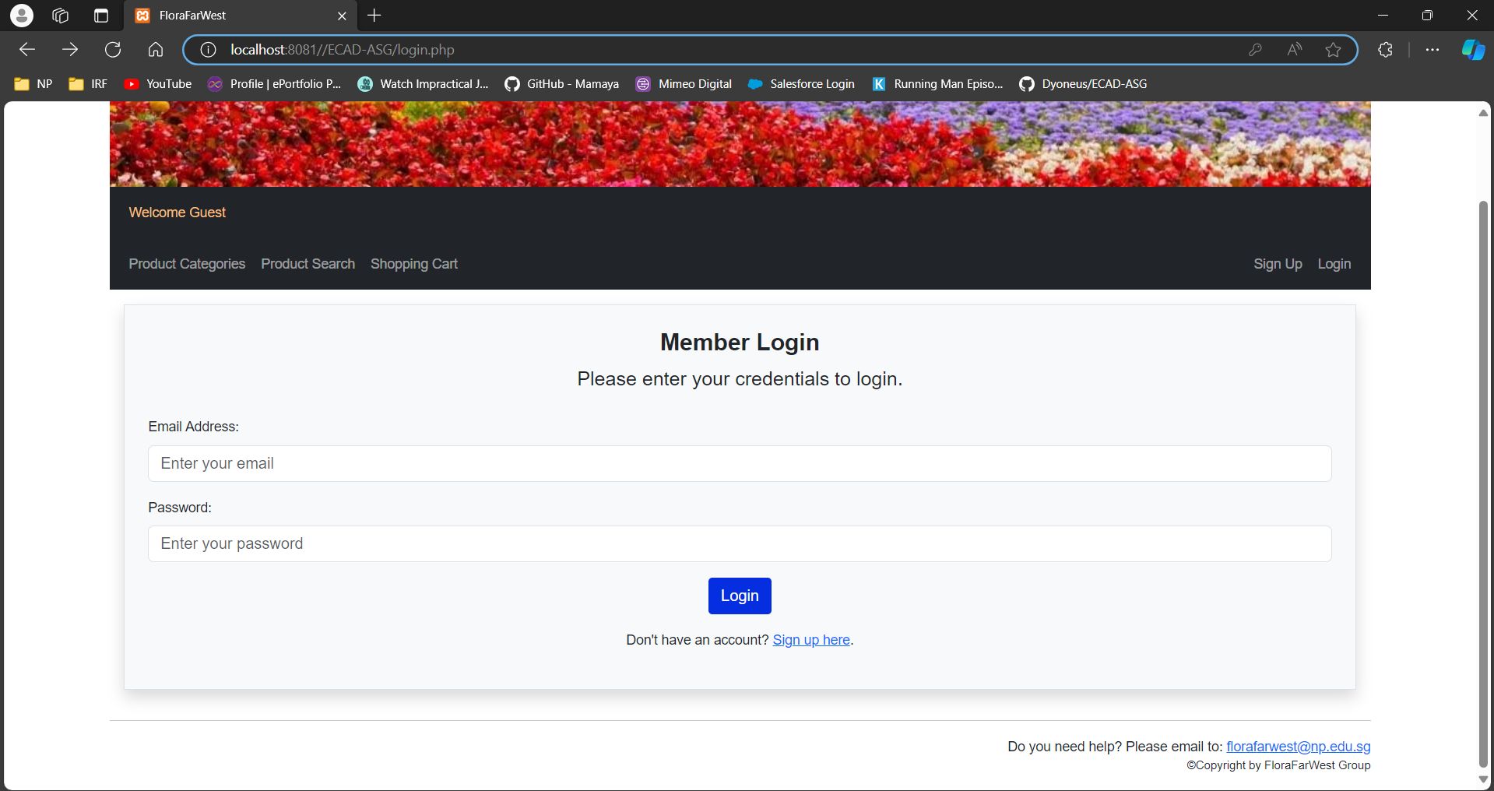

This is the login page for FloraFarWest. In order to purchase a product, a user has to login with its email address and password. If the user is new to FloraFarWest and wishes to purchase a product from FloraFarWest, the user has to register for an account before making any purchase.

Regardless, without logging in, a user can already browse the products, services and promotions offered by FloraFarWest. The user is also allowed to register their account if they do not have one. Validation is also done here if an existing shopper logged in to verify its credentials and error message will be displayed if the credentials are entered incorrectly.

Product Catalog (Individual Component)

Done By: Khoo Jun Jie S10222747H

Features

Product Categories
Link: index.php → category.php

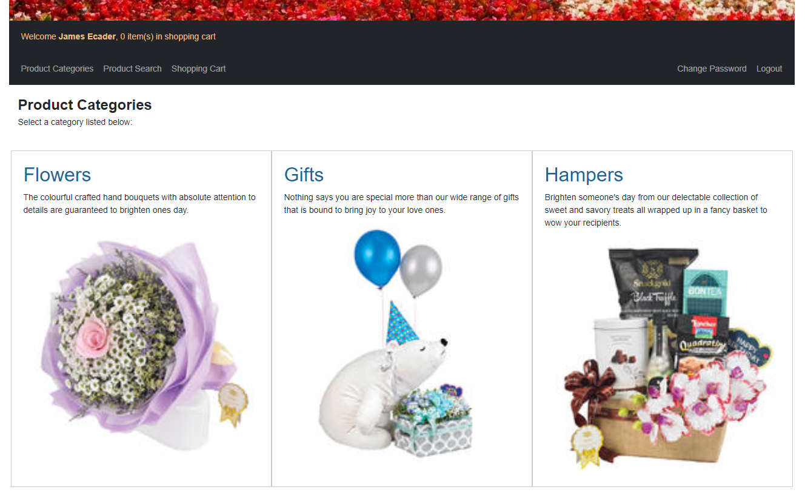

Description:
The screenshot above is the Product Categories page of the gift website. This page shows all the available categories of products sold on this website on a row of 3, which have been categorized into 3 main categories, Flowers, Gifts, and Hampers, sorted in alphabetical order. It displays the name, description, and image of each category in separate containers. The users can select one of the categories and click on the name of the selected category to be redirected to the corresponding Product Listing page for a more detailed exploration of products within the category.

Product Listing
Link: index.php → category.php → catProduct.php

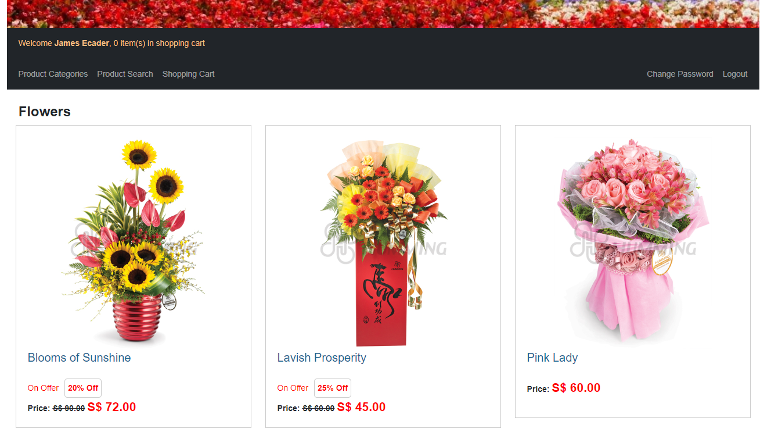

Description:
This product listing page displays all the products of the selected category, arranged alphabetically in distinct separated containers with three items per row. Each container features a large, centered image, accompanied by the product’s name in blue for easy readability and the price in red with larger font size to capture the users’ attention. This layout ensures a pleasant shopping experience for the shoppers, allowing them to view the products clearly. The shoppers can click anywhere on the container of the chosen product to redirect to the product details page, where they can view the additional details of the product and add the item to their shopping cart. This makes navigation through the listings easier and effortless.

Product Details
Link: index.php → category.php → catProduct.php → productDetails.php

Normal
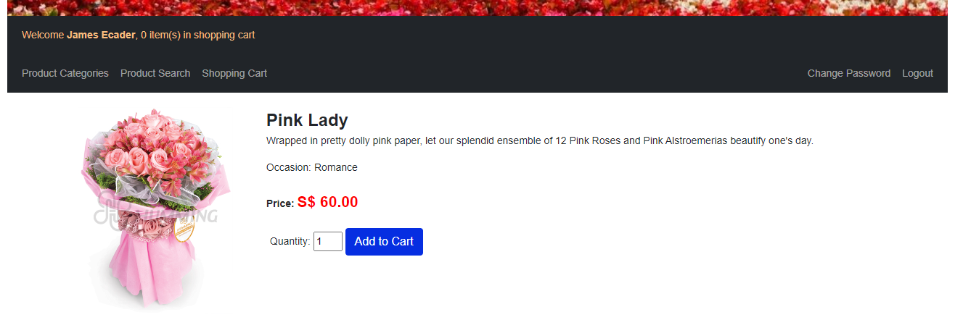

Description:
This page shows comprehensive details of the selected product from the product listing page, including the image, title, description, product specifications such as occasion and weight, as well as the price. Similar to the product listing page, the title and price are bolded and displayed in a larger font size, with the price highlighted in red to attract the shoppers’ attention. Shoppers can easily specify the desired quantity and dd the product to their shopping cart by clicking on the “Add to Cart” button.

Out of Stock
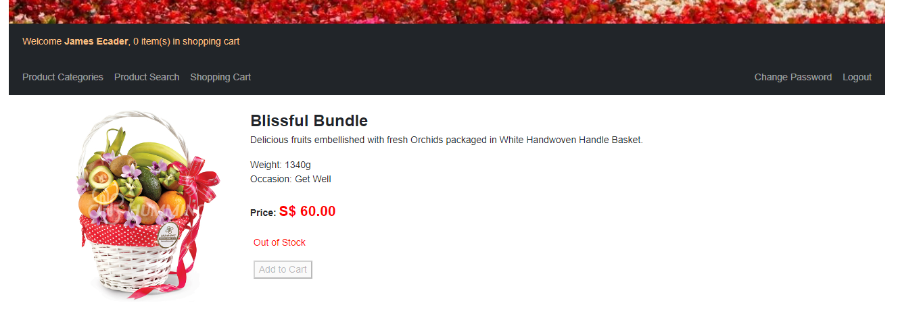

Description:
If the selected product is currently out of stock, an “Out of Stock” indicator in red font color will be displayed on the product details page to alert the shoppers. In such cases, the “Add to Cart” button is also deactivated to prevent the shoppers from adding the item to their shopping cart, effectively alerting them to the item’s unavailability.

On Offer
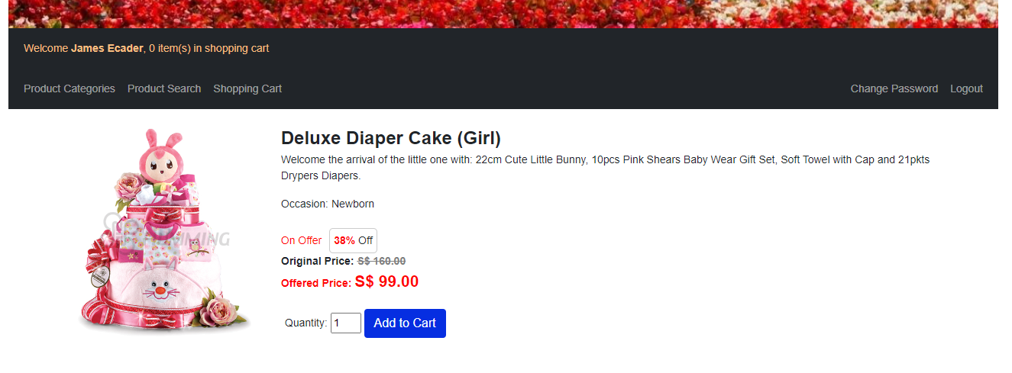

Description:
When the selected item is on offer during the indicated period, an “On Offer” indicator in ed font color is prominently displayed to alert shoppers. The product’s original price is also shown, stuck off, with the offered price boldly presented in red font color. Additionally, a percentage of the offer is indicated in red font color beside the “On Offer” indicator, providing shoppers with a clear visualization of the deal’s attractiveness.

Product Search
Link: index.php → search.php

Simple Search – No Input
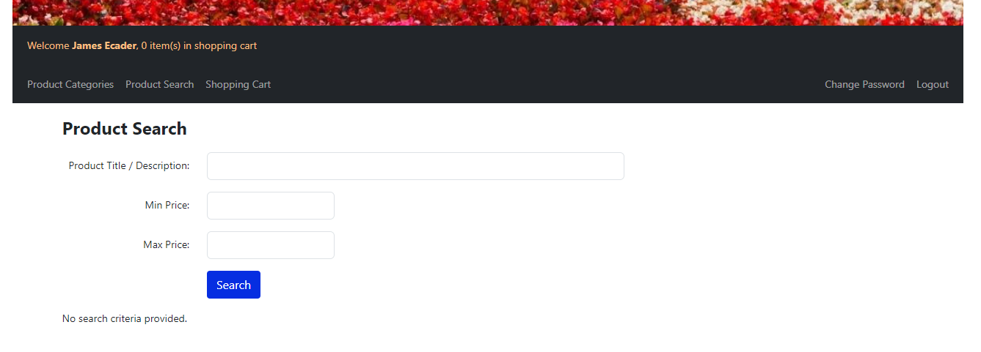

Simple Search – Title/Description Input
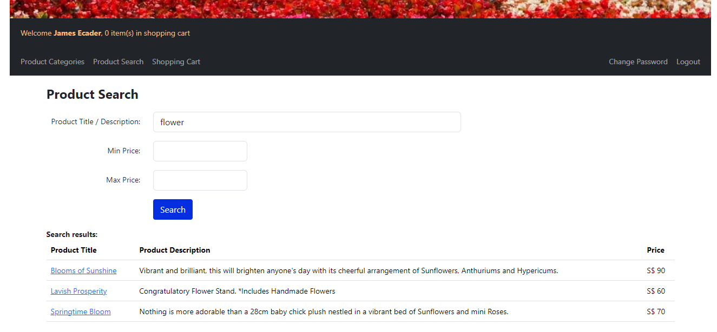

Description:
This page enables shoppers to easily search for products by entering a partial search string of the product’s title or description. Upon entering the search term, the products containing the specified word will be displayed in multiple lines. Product titles are presented in blue color, underlined, and hyperlinked, allowing shoppers to click and seamlessly redirect to the product details page for the corresponding product.

Advanced Search – Price Range (S$60 - S$80)
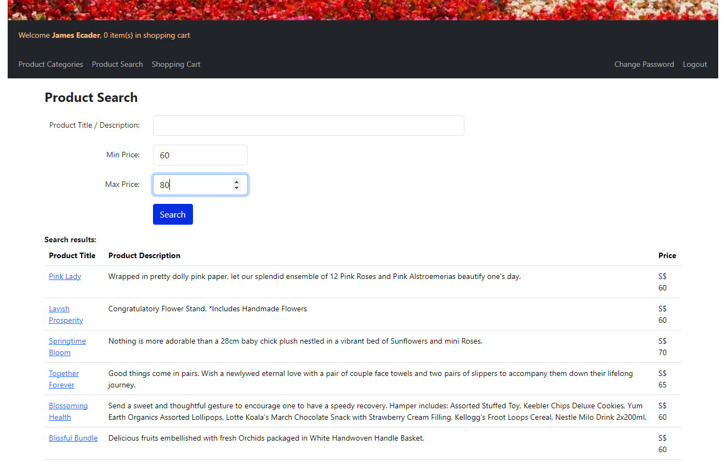

Advanced Search – Title/Description & Price Range (S$60 – S$80)
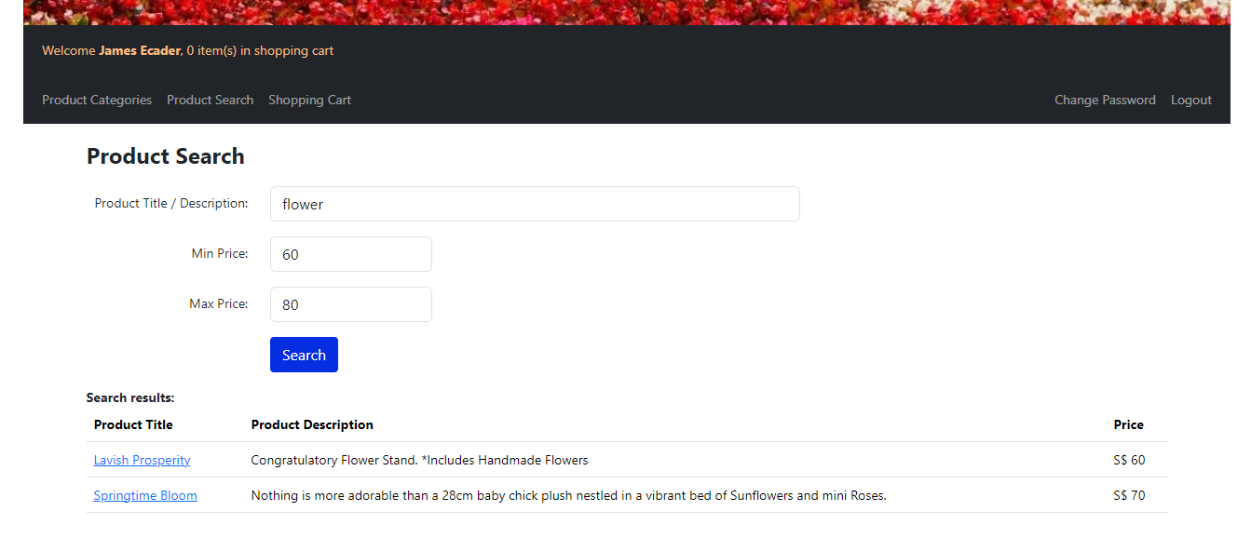

Description:
With the advanced search feature, shoppers can enhance their search experience by entering specific price criteria. They have the flexibility to set either a minimum price, maximum price, or both, and the search results will include products falling within the specified price range. Additionally, shoppers can further refine their search by entering both the product’s title or description and the desired price range simultaneously, providing a more tailored and efficient way to filter the results.

Shopping Cart (Individual Component)

Done By: Ong Jia Yuan S10227735B

Features

Shopping Cart Overview
Link: Index.php → shoppingcart.php

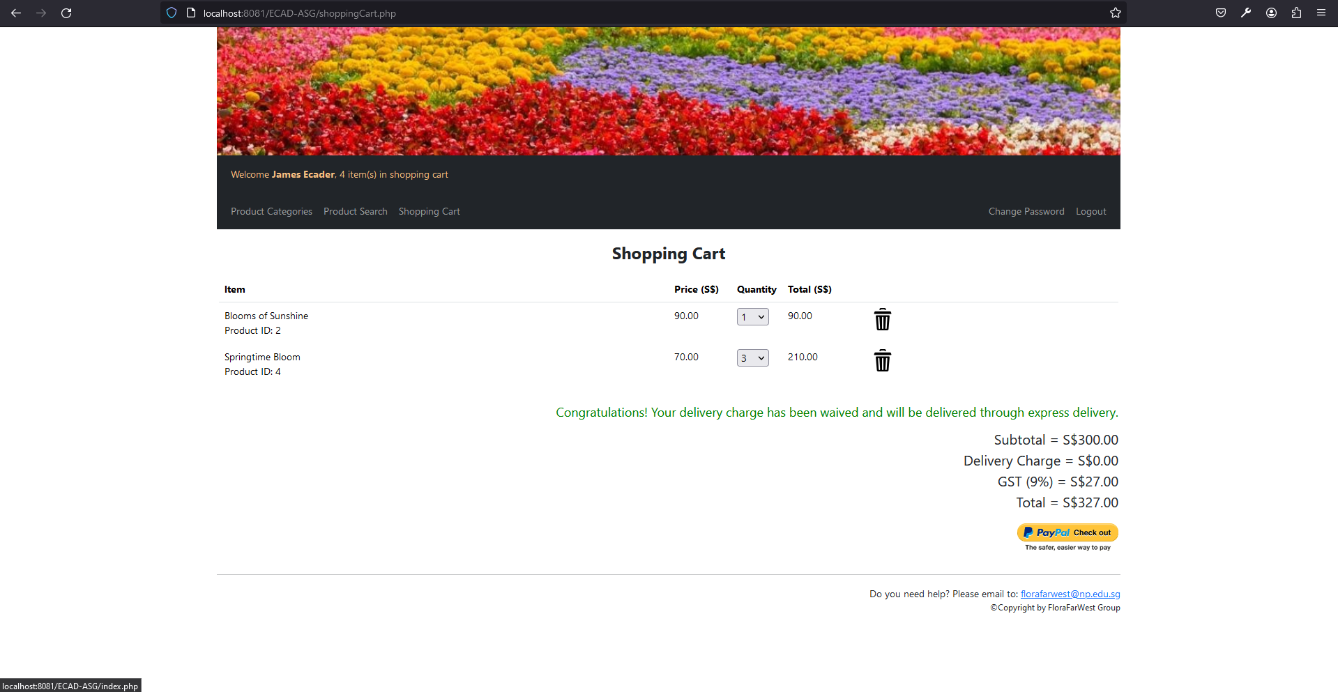

Description:
The Shopping Cart page is a key feature of the FloraFarWest online flower shop, designed to provide users with a clear and concise overview of their selected items before proceeding to checkout. This page is accessible from the navigation bar, displaying a welcoming message with the user's name and the total number of items in the cart (e.g., "Welcome James Ecader, 3 item(s) in shopping cart"). The shopping cart dynamically updates to reflect the current contents, including changes in quantity or item deletions, ensuring a seamless shopping experience.

Add Item to Shopping Cart
Link: Index.php → shoppingcart.php or productdetails.php → shoppingcart.php
Before adding item to cart:
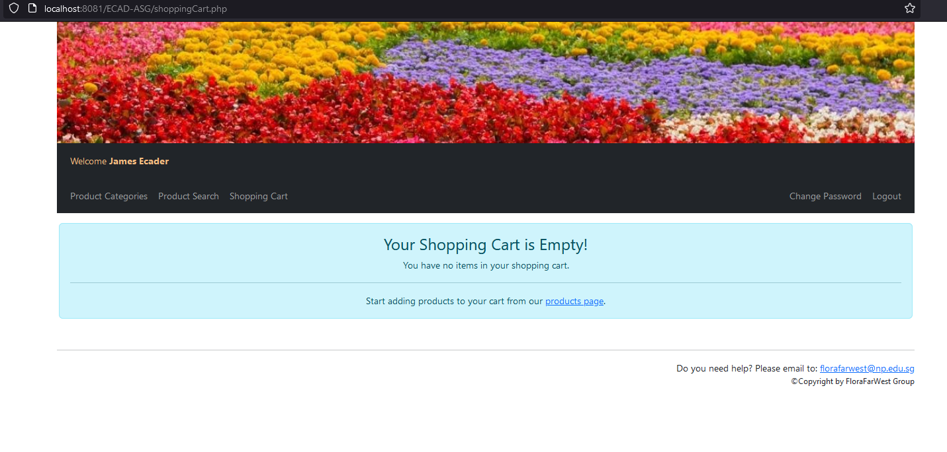
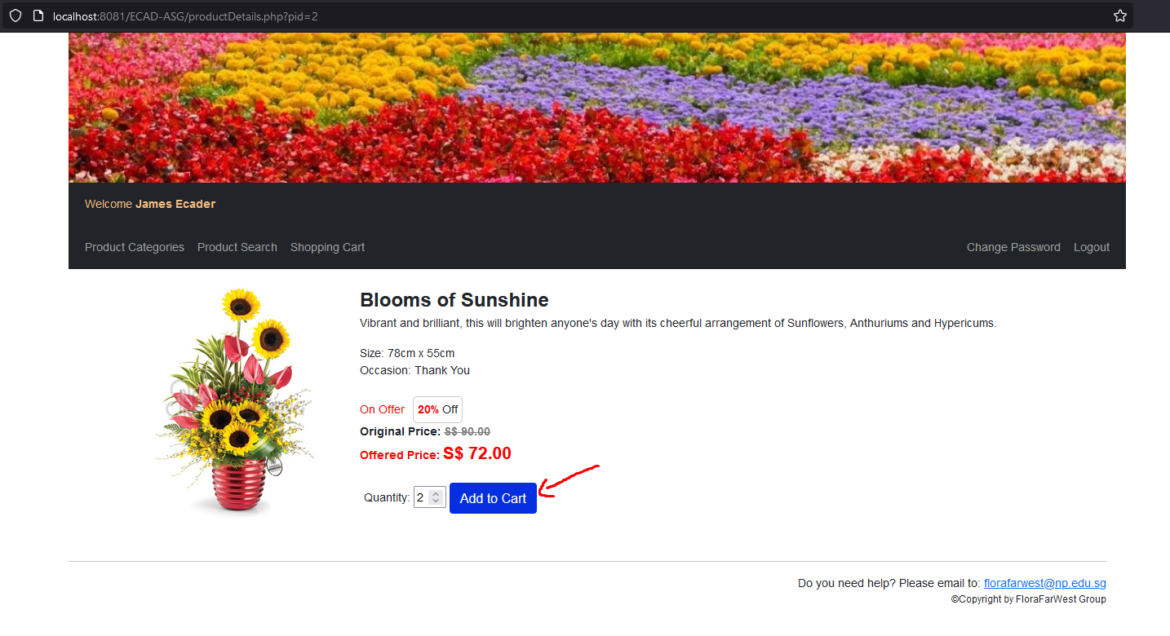
After:
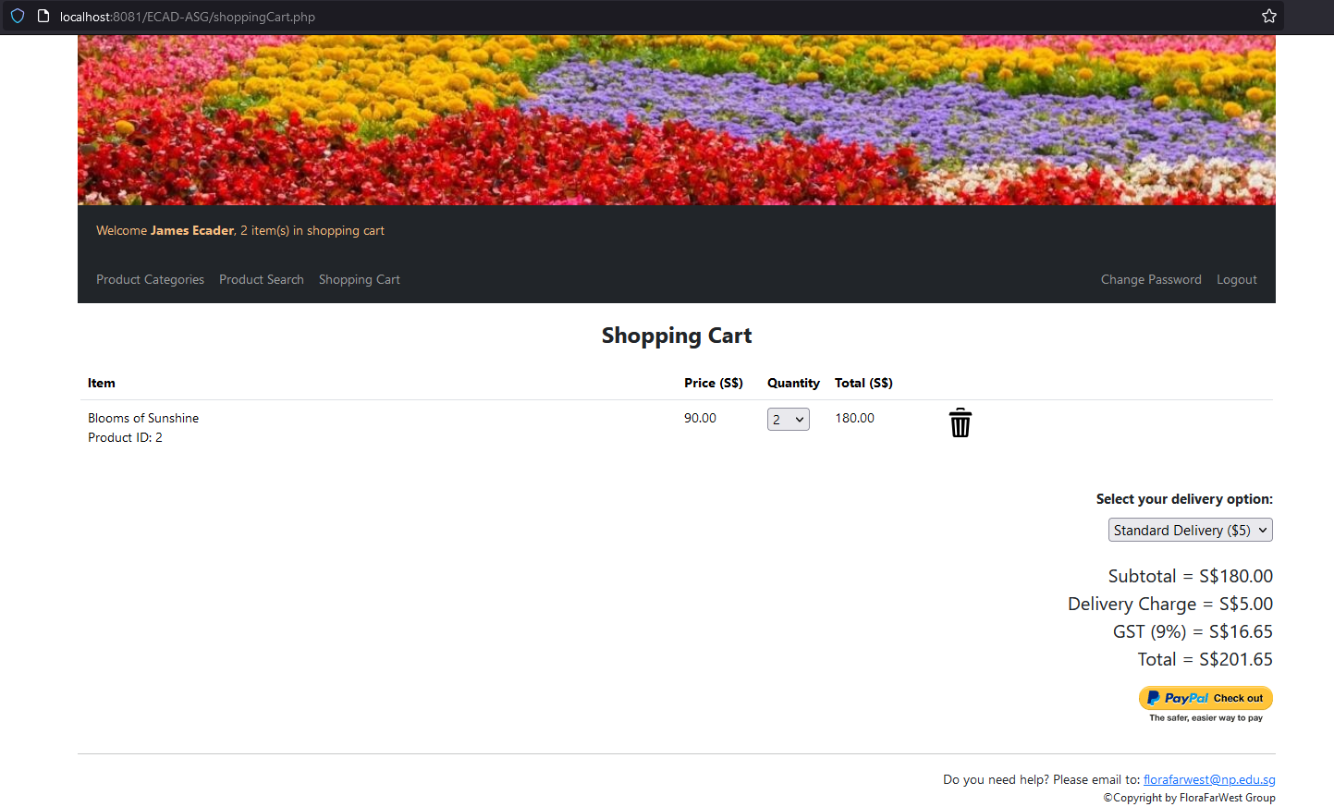

Functionality Integration:
This feature allows users to add products to their shopping cart directly from the product details page. Each addition is instantly reflected in the shopping cart icon on the navbar, updating the total item count. This real-time feedback is crucial for enhancing user engagement and shopping efficiency.

Display and Update Shopping Cart Contents
Link: Index.php → shoppingcart.php
Before changing quantity:

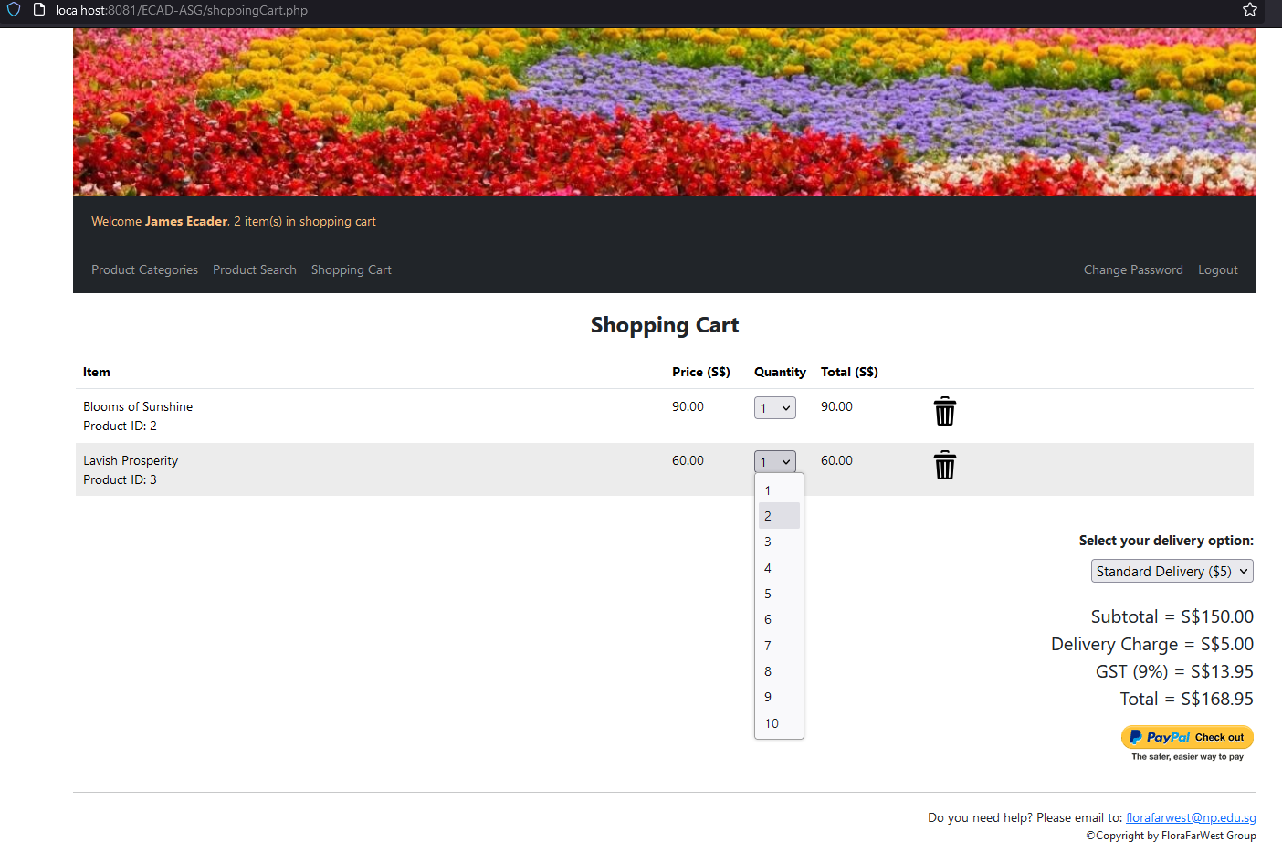
After:
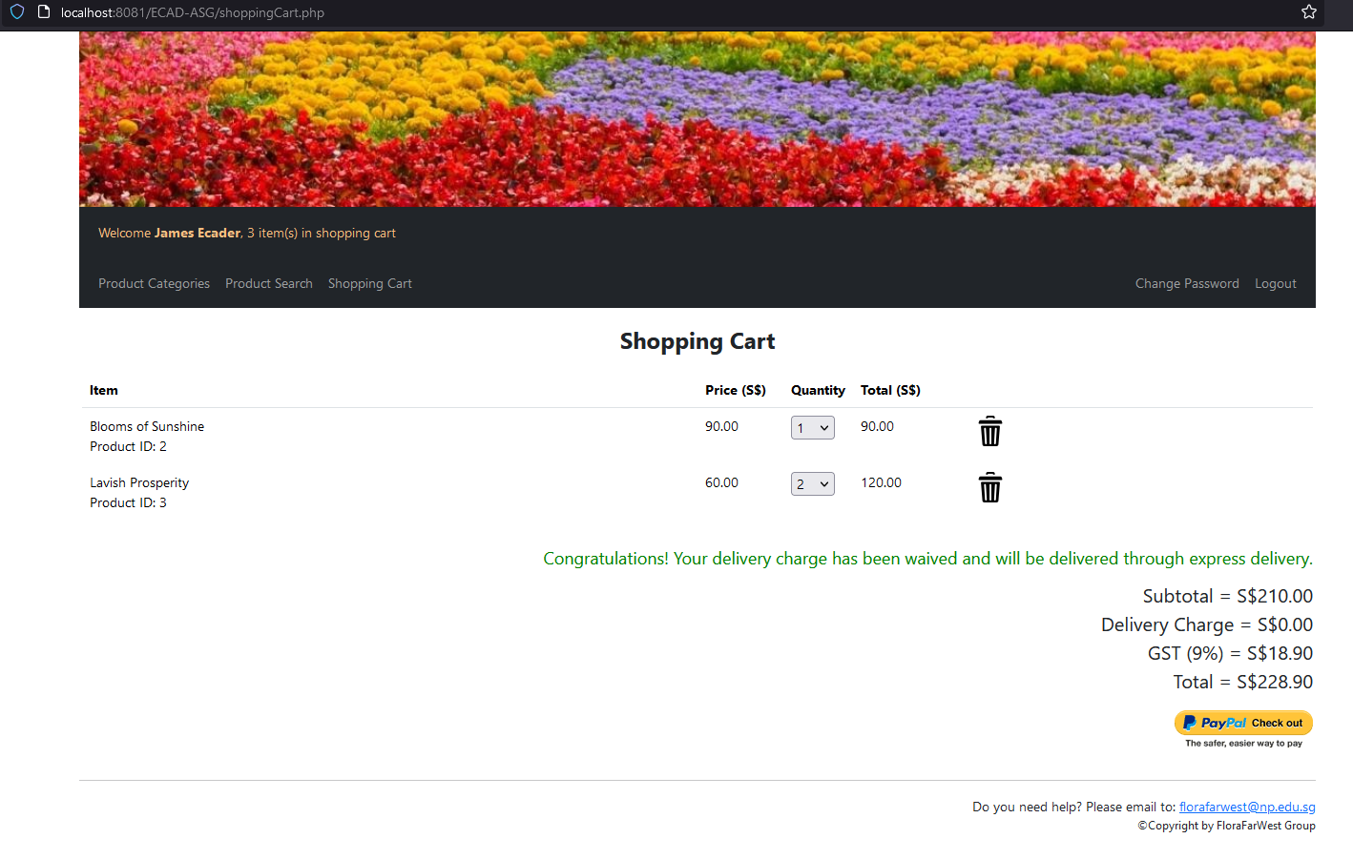

User Interaction:
Upon navigating to the shopping cart page, users are presented with a detailed summary of their cart contents, including product names, unit prices, selected quantities, and the total purchase amount for each item. This layout is designed for easy review and modification of the cart's contents.
- Quantity Adjustment:
Shoppers have the option to update the quantity of each product directly within the shopping cart. This flexibility allows for last-minute changes based on shopper preference or budget considerations.
- Product Deletion:
An option to remove individual items from the shopping cart is provided, enhancing the customizability of the shopping experience. This feature is particularly useful for users wishing to prioritize certain products or adjust their overall purchase before checkout.

Additional Features

Dynamic Shopping Cart Indicator

Link: Index.php → shoppingcart.php

Before change of quantity):
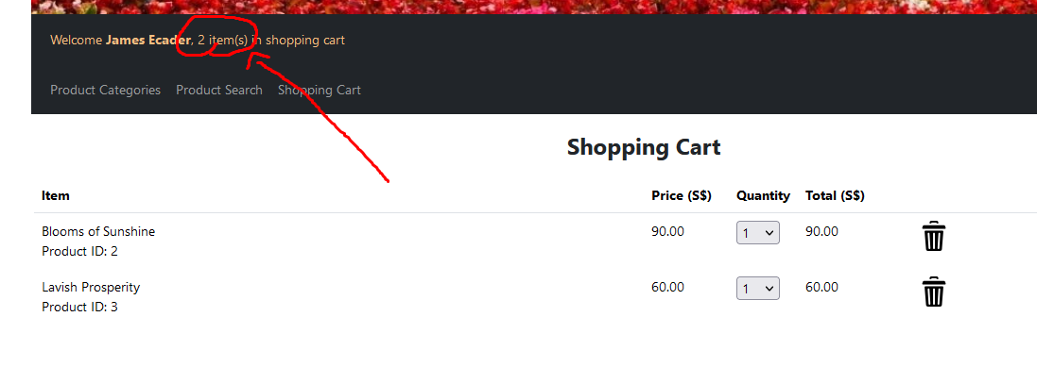
After:
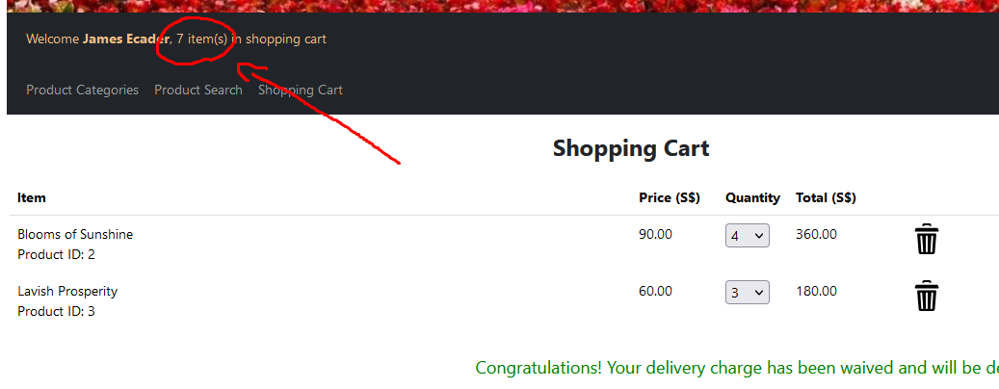

Functionality:
A dynamic indicator on the navbar provides users with a real-time count of the items in their shopping cart. This feature is designed to enhance user navigation, making it easier for users to keep track of their potential purchases as they continue to browse through the online shop.

Delivery Fee Waiver Notification
Link: Index.php → shoppingcart.php
Before:
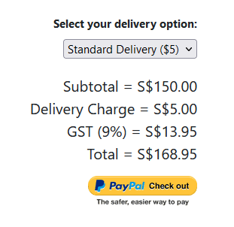
After:
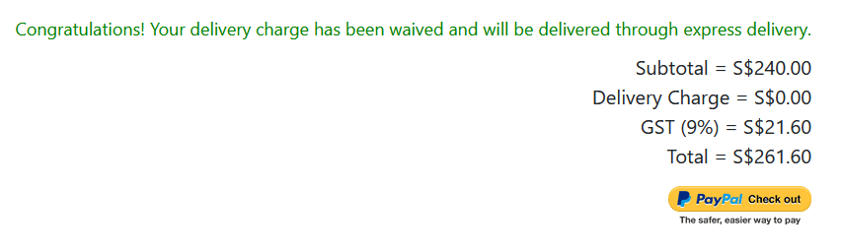
Customer Incentive:
When the subtotal of the items in the shopping cart exceeds $200, a notification is displayed to the user, indicating that the delivery fee has been waived. This automated feature serves as a direct incentive for users to increase their purchase amounts, benefiting both the customer with savings and the business with increased sales.

Pricing reflects Item price after sale
Link: Index.php → shoppingcart.php
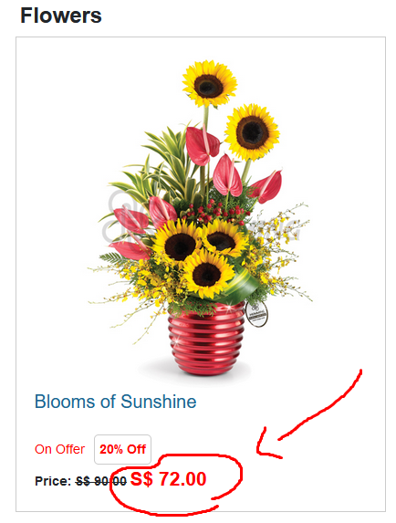
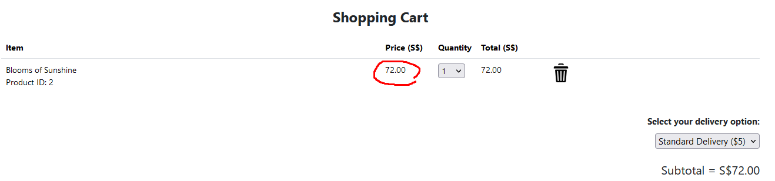
Description: |
This feature is visible on the Shopping Cart page, where each item listed includes the original price with a strikethrough (if a discount is applicable) and the discounted price in red. The shopping cart's total reflects the sum of the discounted prices, ensuring that shoppers have a clear understanding of the total amount payable before proceeding to checkout. This instant visual feedback on savings helps to improve the overall shopping experience and can encourage further purchases.

Checkout (Individual Component)

Done By: Owen Wong Hoi Yang S10222049J

Features

Shopping Cart Delivery
Link: Index.php → shoppingcart.php or productdetails.php → shoppingcart.php

When subtotal < $200

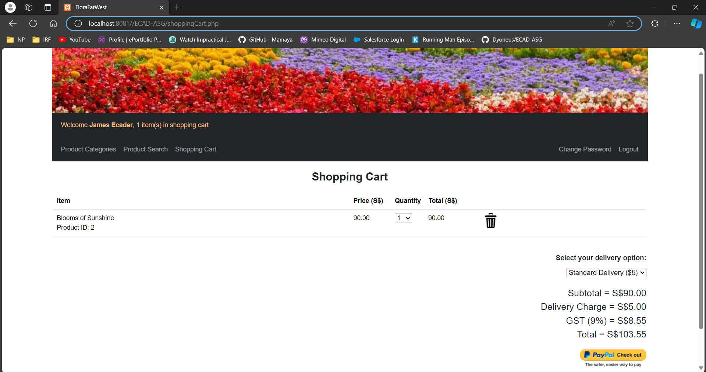
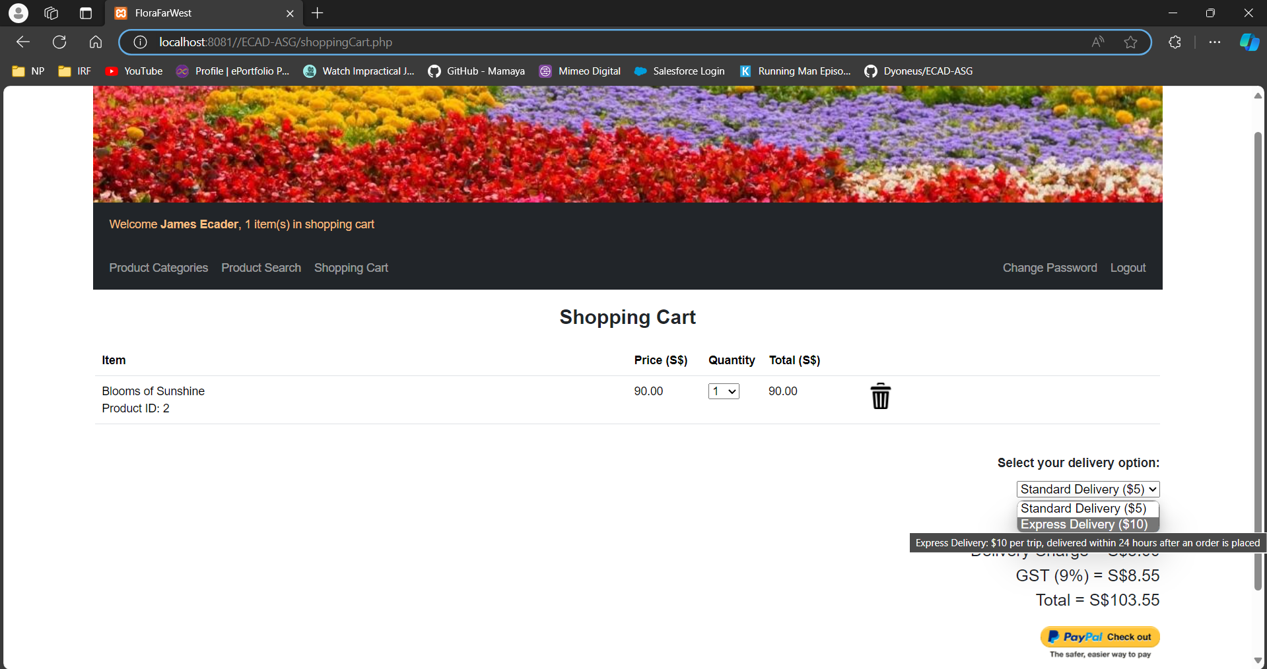

When subtotal > $200

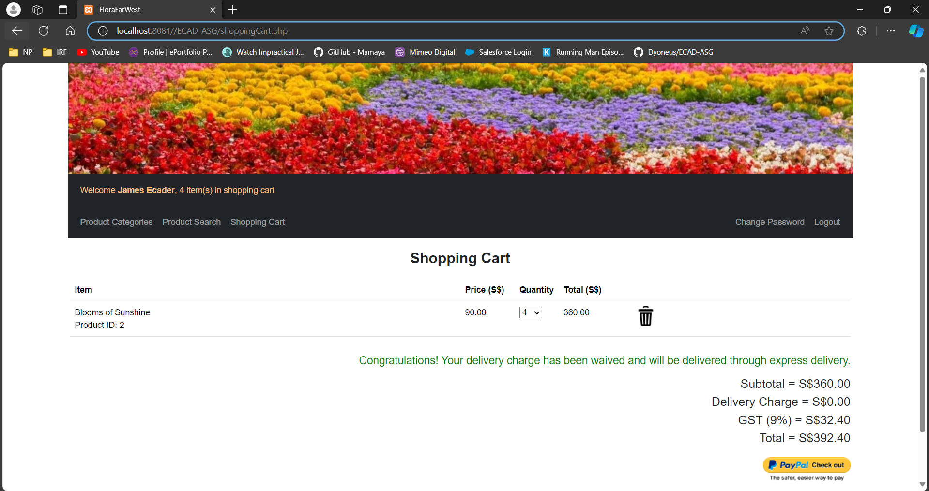

Description:
The screenshot above shows the shopping cart page. To access the shopping cart page, the user has to login as a member first. On this page, the user can see the product(s) which he/she added to their shopping cart, they are also able to choose between the 2 different modes of delivery - normal and express delivery. Normal delivery costs $5 and the product will only be delivered within 2 working days while express delivery costs $10 and will be delivered within 24 hours.

The default delivery mode is normal delivery. Hence, the default option and delivery fee are set at $5. If the user were to select the express delivery, the dropbox and delivery fee would change to $10. If the subtotal amount is more than $200, the delivery charge will be waived, and express delivery will be the delivery mode. The user can check out by clicking on the “Paypal check out” button at the bottom right of the shopping cart page.

Not Enough Stock
Link: Index.php → shoppingcart.php or productdetails.php → shoppingcart.php → checkoutProcess.php

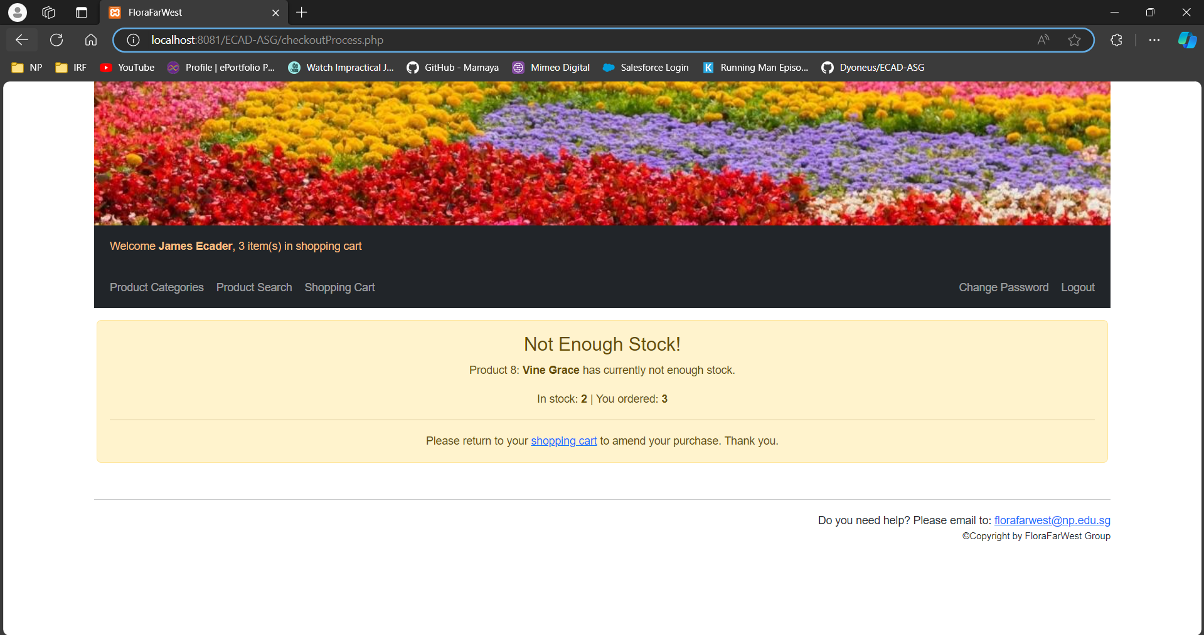

Description
Upon clicking the “Paypal check out” button, if the system detects that there isn’t enough stock of what the user wants to buy, the page will show that there is “Not Enough Stock!”. It will also show which product does not have enough stock and show how much is in stock for the user to buy. Ther user will be able to click the hyperlink to redirect the user back to the shopping cart to edit their cart.

PayPal
Link: Index.php → shoppingcart.php → mypaypal.php
When subtotal < $200

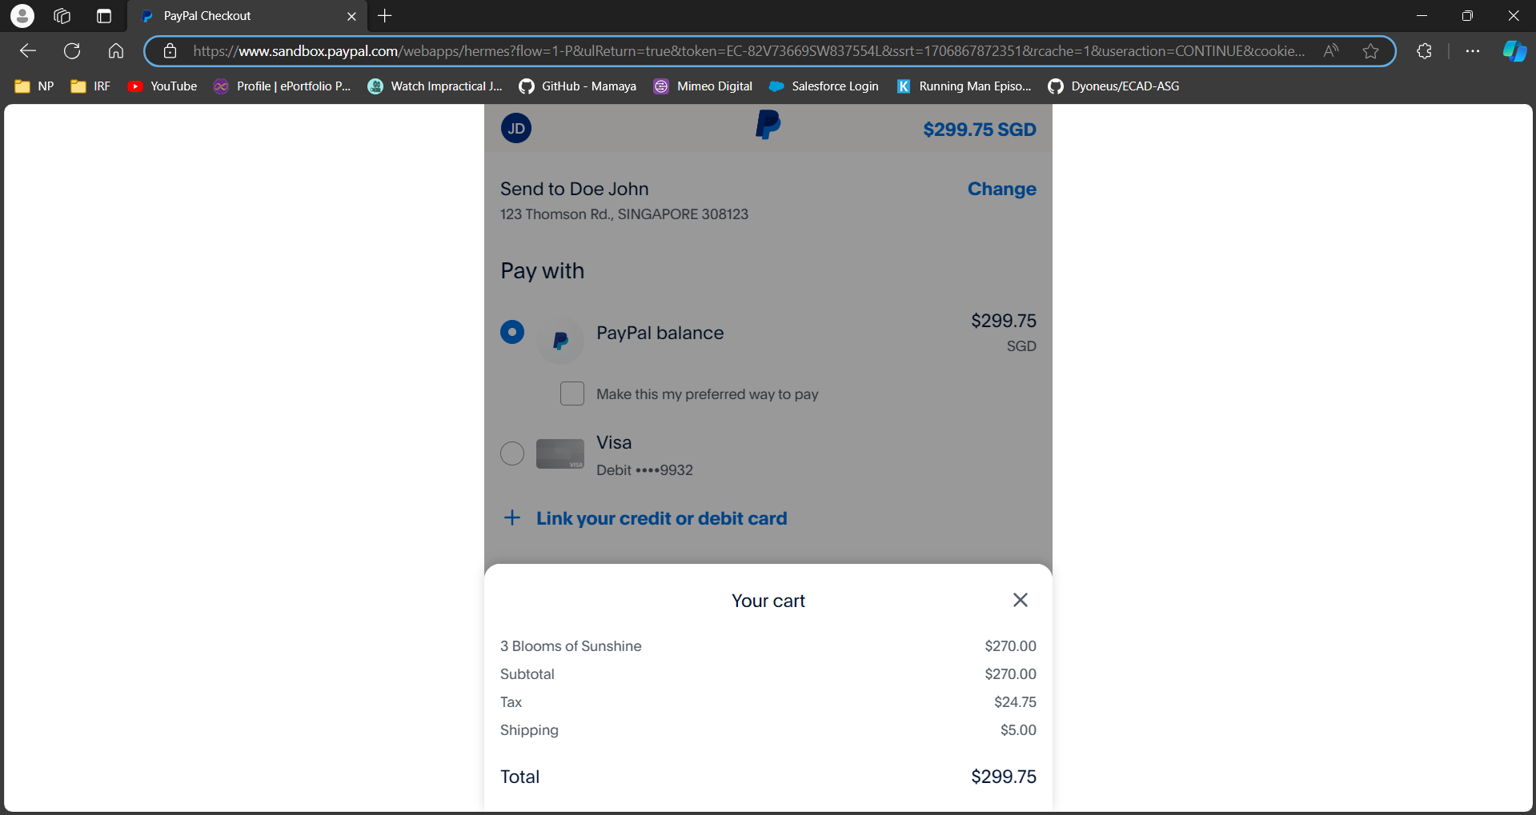

When subtotal > $200

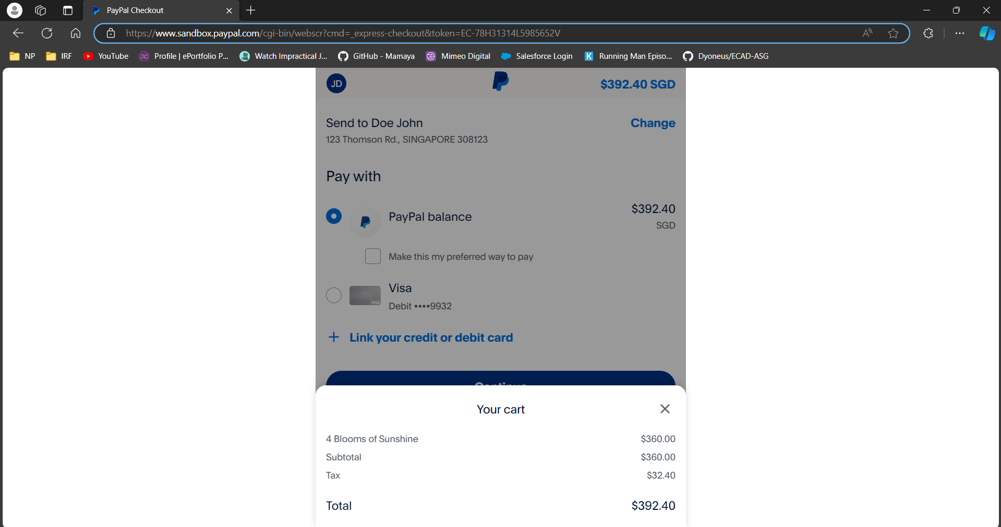

Description:
Upon clicking the “Paypal check out” button, the user will be redirected to the paypal page. On this page, the user can change their delivery address if necessary and the details of his/her purchase is shown - the product name and price, total costs of the
items, gst price calculated based on the current gst rate, delivery fee based on the type of delivery method the user chose on the shopping cart page and total amount to be paid. If the amount is more than $200, the delivery fee will be waived so the delivery fee will not be shown.

Order Confirmation page
Link: Index.php → shoppingcart.php → mypaypal.php → orderconfirmed.php

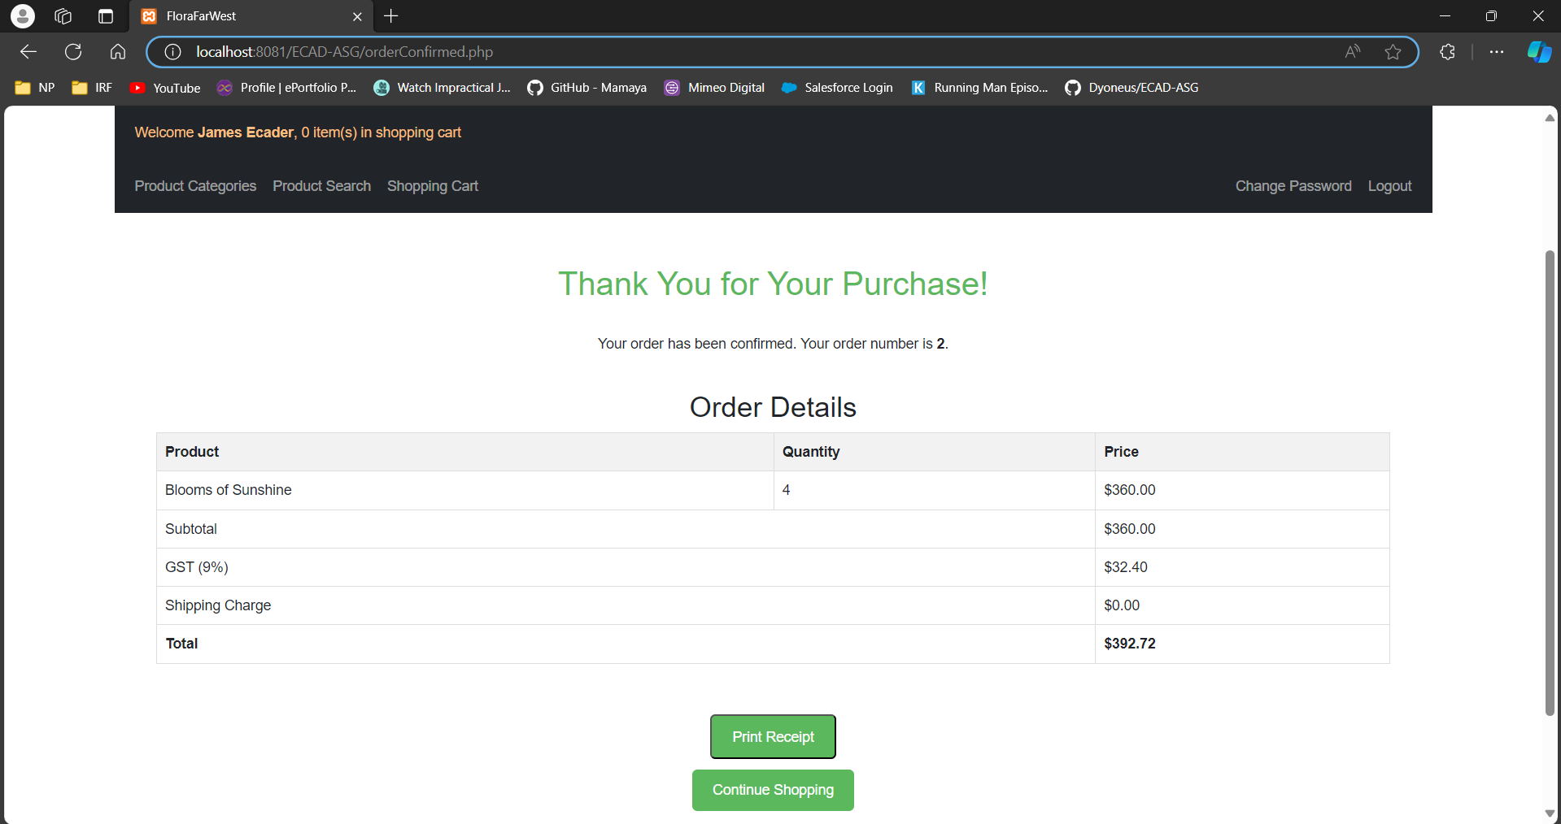

Description
When the checkout is successful, the user will be redirected to this confirmation page. On this confirmation page, the user can see the order ID of their order for future references. This page also shows the purchased product name and quantity, and amount breakdown paid. Additionally, after the order is confirmed, the inventory level in the database will be updated accordingly. After checking out, if there are any items that the user forgot to purchase, there is a button to redirect the user back to the home page to continue their shopping.

Additional Features

Payment Breakdown
Link: Index.php → shoppingcart.php or productdetails.php → shoppingcart.php

Description
Calculation of the tax payable based on the current GST rate retrieved from the database. Also shows the subtotal, delivery charge, GST and total amount to be paid similar to the paypal page.

Print Receipt
Link: Index.php → shoppingcart.php → mypaypal.php → orderconfirmed.php → printReceipt.php

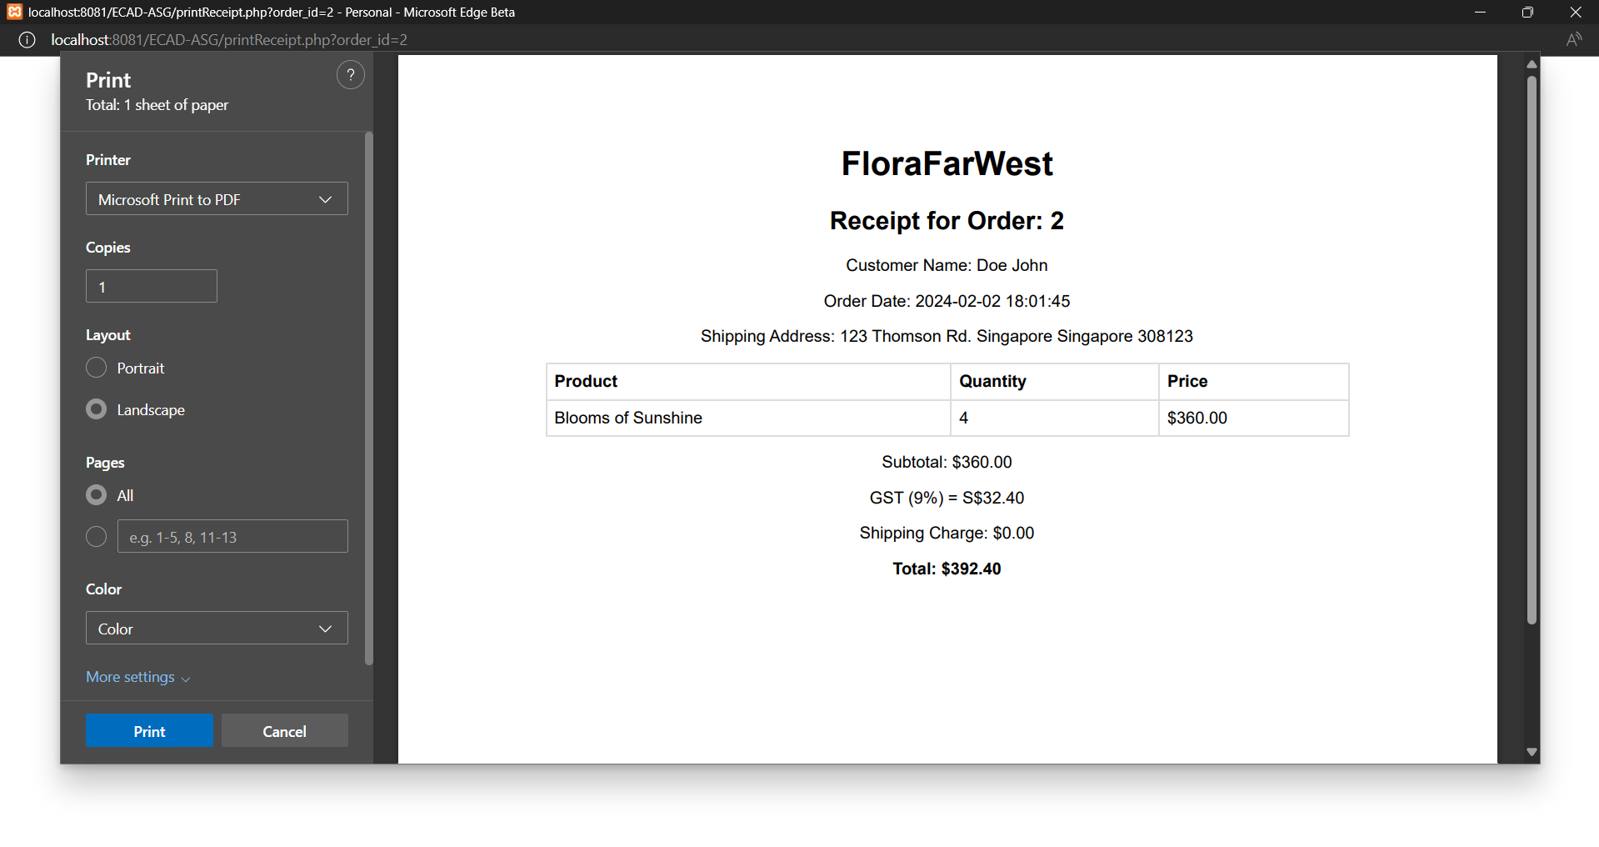
Description
After checking out, if users would like to print a receipt, they would be able to click the print receipt button and it will generate a receipt for the user to print with the printing function at the side. It will show the order id, customer name, order date, shipping address, product, quantity, price and the amount breakdown for ease of reference.

References
“Logo Design for FloraFarWest e-store." Created using AI-based design tool, [30th January 2024]

